**Transfer Files from S3 to EFS using Datasync**

Create EFS and mount it into Linux instance.

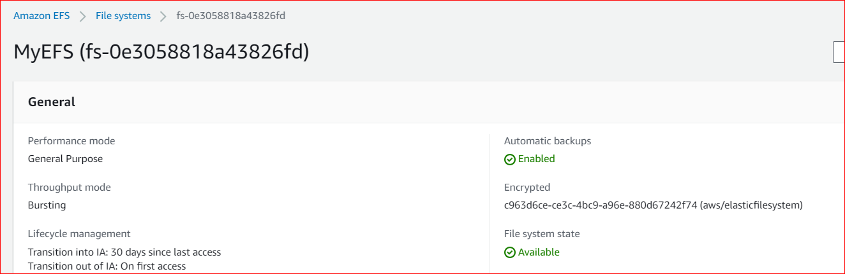

Launch Linux EC2 instance and Mount EFS

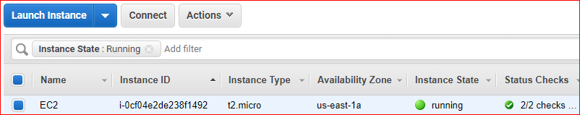

# mount -t nfs4 -o nfsvers=4.1,rsize=1048576,wsize=1048576,hard,timeo=600,retrans=2,noresvport fs-0e3058818a43826fd.efs.us-east-2.amazonaws.com:/ efs



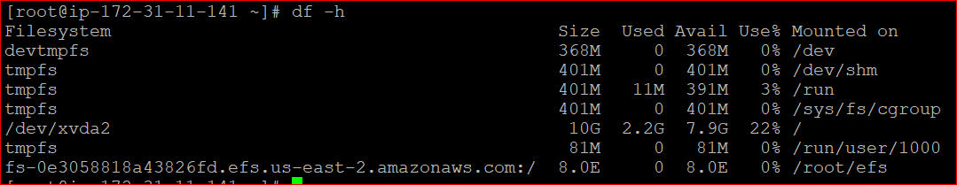

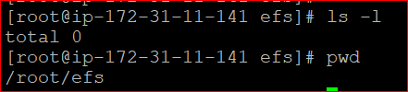

Create Task in Datasync

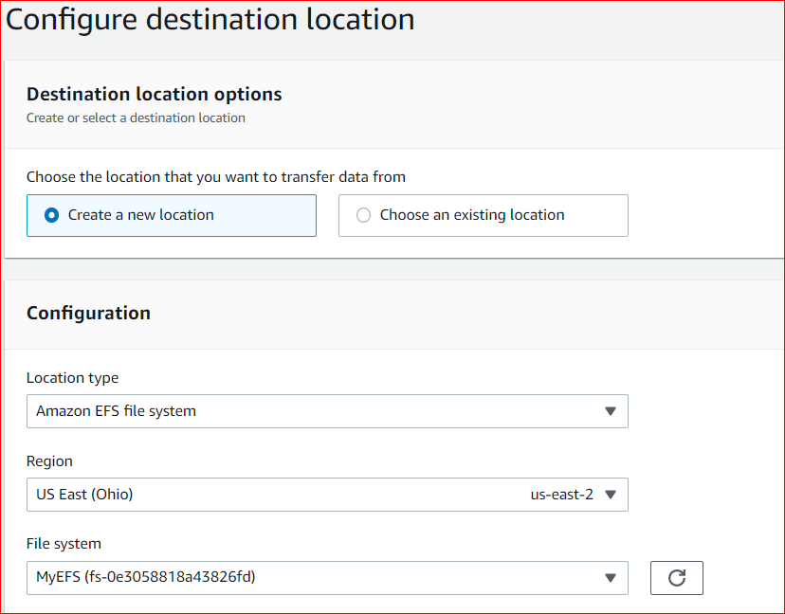

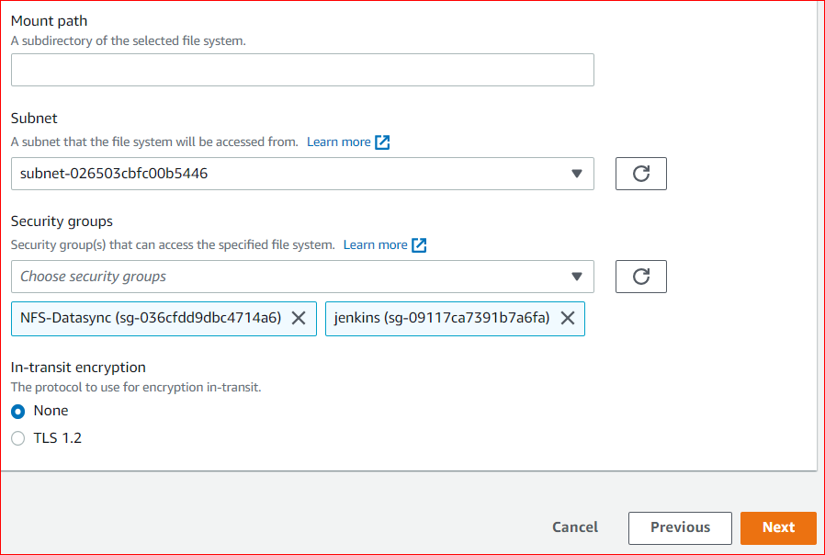

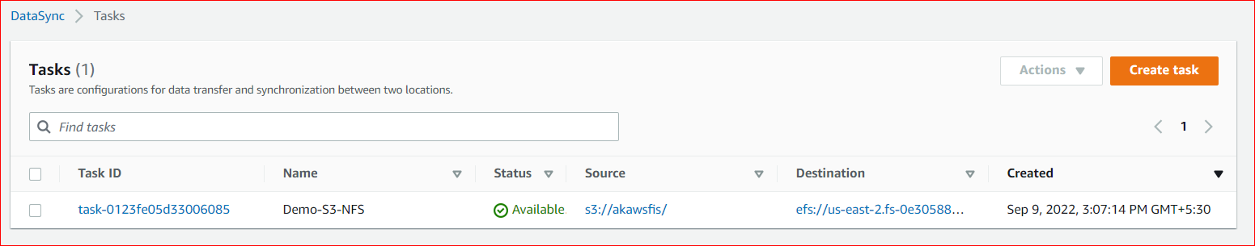

Start the task once created.

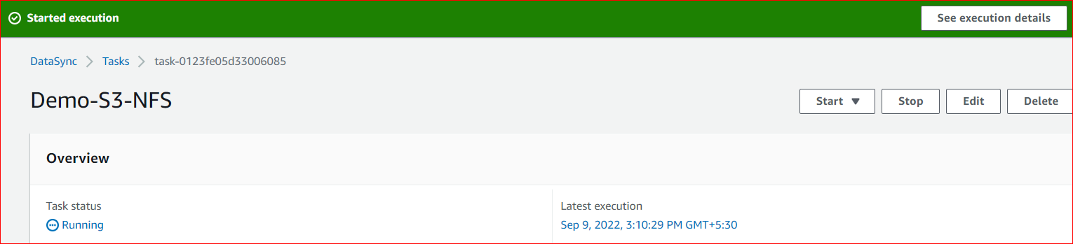

Transfer completed

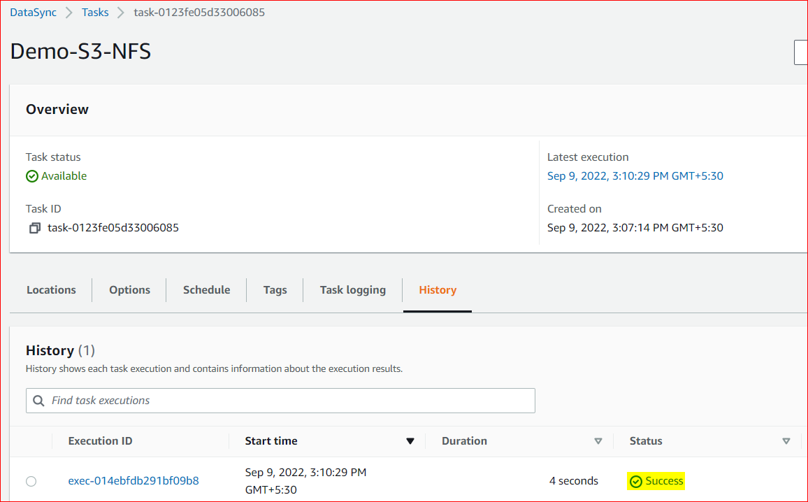

Check the file availability in EFS file system.

